CHILDREN’S BOOK CORNER
Here is a selection of books related to the holidays and special days of this month, recommended for your child’s reading pleasure.


INTERNATIONAL DAY FOR THE ABOLITION OF SLAVERY ~ December 2nd
AN AMERICAN STORY
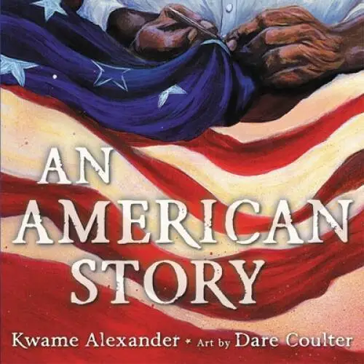
Kwame Alexander, author, Dare Coulter, illustrator,

Overview: This book gives voice to the numerous Africans who lost their lives during the slave trade or were enslaved. It deals with the telling of the story of people that suffered through the hardship of slavery. It speaks of the hope for a future, a freedom that would be obtained one day.

UNICEF (United Nations Children’s Fund) Foundation Day ~ December 11th
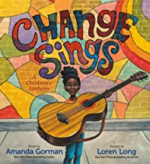
CHANGE SINGS: A Children’s Anthem
Amanda Gorman, author Loren Long, illustrator,
Overview: Written by New York Times bestselling author, Amanda Gorman, this book is about change being a song sung by children. It’s a song of dreams, love, strength, tolerance, courage and freedom. This book is an invitation to change. It tell the reader that change is inside of everyone, just waiting to get out.

CHRISTMAS ~ December 25th
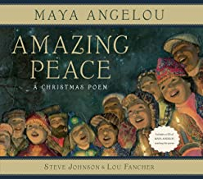
AMAZING PEACE: A Christmas Poem
Maya Angelou, author Steve Johnson and Lou Fancher, illustrator
Overview: This book is an illustrated version of a poem by Angelou. The poem is a radiant affirmation of the goodness of humanity. It tells of the promise of peace in the holiday season.
Note: Most editions of this book contain a CD of the poem read by the author.

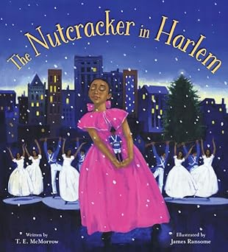
THE NUTCRACKER IN HARLEM
T. E. McMorrow, author James Ransome, illustrator
Overview: Set in New York City during the height of the Harlem Renaissance, one little girl finds her voice as a musician thanks to her enchanting adventures with a magical toy.
An author’s note at the end provides additional information about the history of the Harlem Renaissance.

KWANZAA ~ December 26th – January 1st

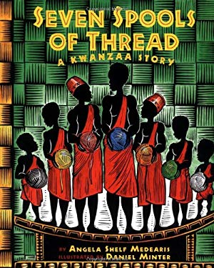
SEVEN SPOOLS OF THREAD: A Kwanzaa Story
Angela Shelf Medearis, author Daniel Minter, illustrator .Overview: When they are given the seemingly impossible task of turning thread into gold, the seven Ashanti brothers put aside their differences, learn to get along, and embody the principles of Kwanzaa.
Contains information on Kwanzaa; West African cloth weaving; and instructions for making a belt.

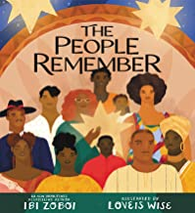
THE PEOPLE REMEMBER
Ibi Zoboi, author, Love Is Wise, illustrator,
Overview: Using the seven principles of Kwanzaa, as an outline, this book tells the story of African Americans from being captive slaves through their fight for freedom and equality in America. It tells of the various African tribes that became Americans (unity); their struggle for freedom (self-determination); their various jobs and duty (collective work and responsibility); their growing wealth (cooperative economics); their times of protest (purpose); their expressions of the heart through music and words (creativity); and it tells how through it all, the people remember (faith).

